Lab 12 Identifying & Analyzing Network/Host Intrusion Detection System (NIDS/HIDS) Alerts

1. Use Zenmap to Scan Network Targets

In this task, you will use the integrated zenmap tool in Kali to create traffic data that can be later analyzed.

1. Launch the SecOnion virtual machine.

2. On the login screen, type soadmin as the username and mypassword as the password. Click Log In.

3. Once logged in, click the start button, followed by clicking on Terminal Emulator to launch a new terminal.

4. Type the command below, followed by pressing the Enter key. If prompted, enter mypassword for root privileges.

soadmin@Security-Onion:~$ sudo service nsm status

5. Launch the Kali virtual machine to access the graphical login screen.

6. Log in as root with toor as the password. Open the Kali PC Viewer.

7. Click on the Applications Menu option located on the top menu pane and navigate to Kali Linux > Information Gathering > Network Scanners > zenmap.

8. A new Zenmap window will appear. Type 203.0.113.1 192.168.1.0/24 10.1.1.0/28 into the Target whitespace.

9. Modify the Command section so that it is written like so. Click the Scan button.

10. Once the scan finishes, examine the output and take notice of which common ports are opened on which system.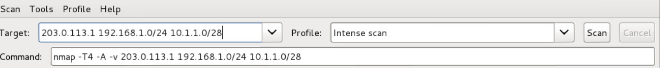

2. Network Security Monitoring with Sguil

2.1. Running Sguil

1. Change focus to the SecOnion system.

2. Double-click the sguil desktop icon to launch the application.

3. A new window will appear. Type soadmin for the username and mypassword as the password. Leave the remaining fields at default values. Click Ok to log in.

4. Check all checkboxes by clicking on the Select All button, followed by clicking on Start SGUIL.

5. Notice upon login, the RealTime Events tab is already populated with events as Sguil is actively running in the background.

6. Change focus to the Kali system.

7. Focus on the Zenmap application. If Zenmap is not already open, open a new terminal and type zenmap followed by pressing Enter to launch the application.

8. Within the Zenmap window, type 10.1.1.10 as the Target.

9. Select Intense scan as the Profile.



10. Verify that the command being used is set to nmap -T4 -A -v 10.1.1.10. Click Scan.

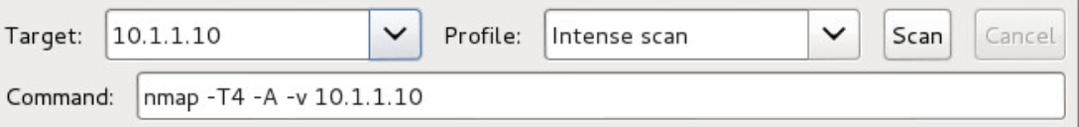

11. Once the scan finishes, change focus back to the SecOnion system.

2.2. Analyzing Network Events using Sguil

1. While viewing the Sguil monitoring application, organize the events by date. Click on the Date/Time column header, making sure that the latest events show up in a descending order.

2. Notice the event under Event Message, noting that an ET SCAN NMAP OS Detection has been detected. Select the event.

3. In the bottom-right pane, check the box for Show Packet Data and Show Rule.

4. 4. Analyze the packet data.

5. Export a detailed report for this specific event to present to management. While having the event selected (highlighted), click on the Reports menu option located on the top menu pane and select Export Events to a Text File (Detail) > Normal.

6. In the Select a Text Report Type window, click OK to continue.

7. In the Save As window, verify the directory is set to /home/soadmin. Type report1 as the filename and click Save.

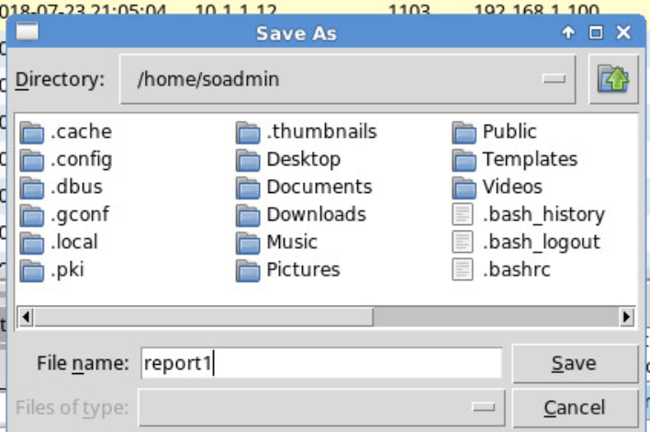

8. Click OK to confirm the file has been saved.

9. While on the SecOnion system, open a terminal and type the command below to view the contents of the report.

soadmin@Security-Onion:~$ cat /home/soadmin/report1

10. After viewing the report in the terminal, close the terminal window.

11. Close the Sguil application.

12. Leave the SecOnion viewer open to continue with the next task.

3. Network Security Monitoring with Squert

3.1. Analyzing Security Monitoring using Squert

1. While on the SecOnion system, double-click on the Squert desktop icon.

2. A Firefox web browser should appear. Verify the address field is populated with the following: https://localhost/squert. Click on Advanced followed by clicking the Proceed to localhost link.waq



